Project Development Phase
Performance Test

Date | 28 June 2025
Team ID | LTVIP2025TMID35377
Project Name | Smart Sorting Transfer Learning for Identifying Rotten Fruits and Vegetables
Maximum Marks

Model Performance Testing:
Project team shall fill the following information in model performance testing template.
S.No. | Parameter | Screenshot / Values
 | Data Rendered | 2,000+ image records rendered with metadata (label: Fresh/Rotten, type: Fruit/Vegetable, etc.)  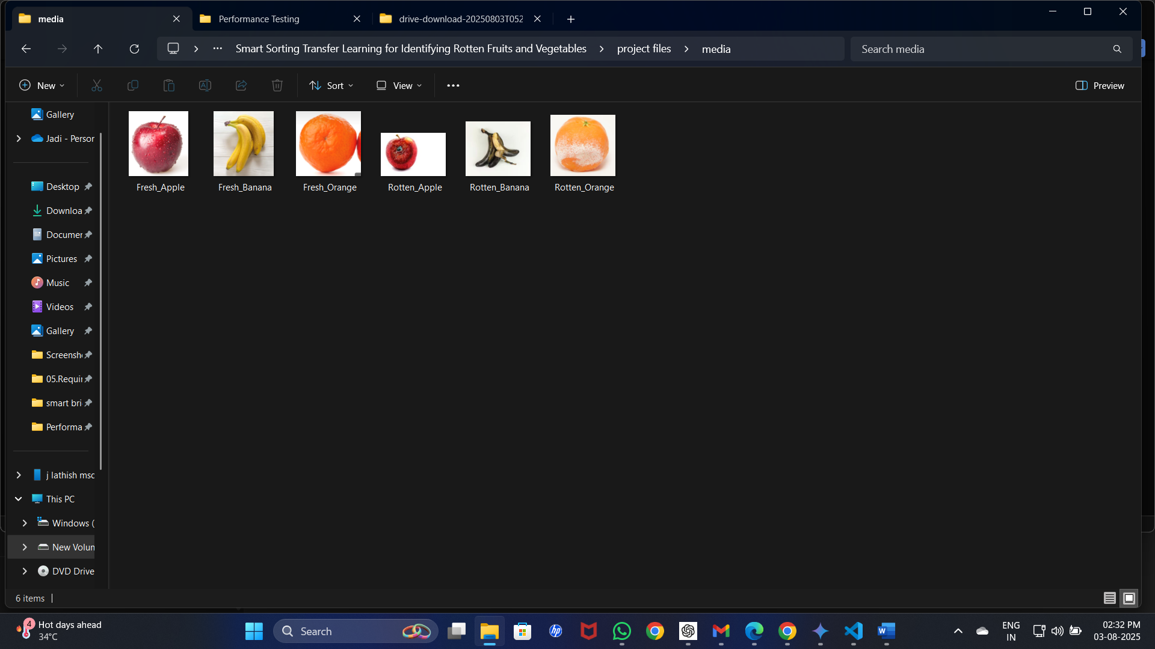
 | Data Preprocessing | Null values removed, categorical encoding (label encoding), resizing of images, format conversion done  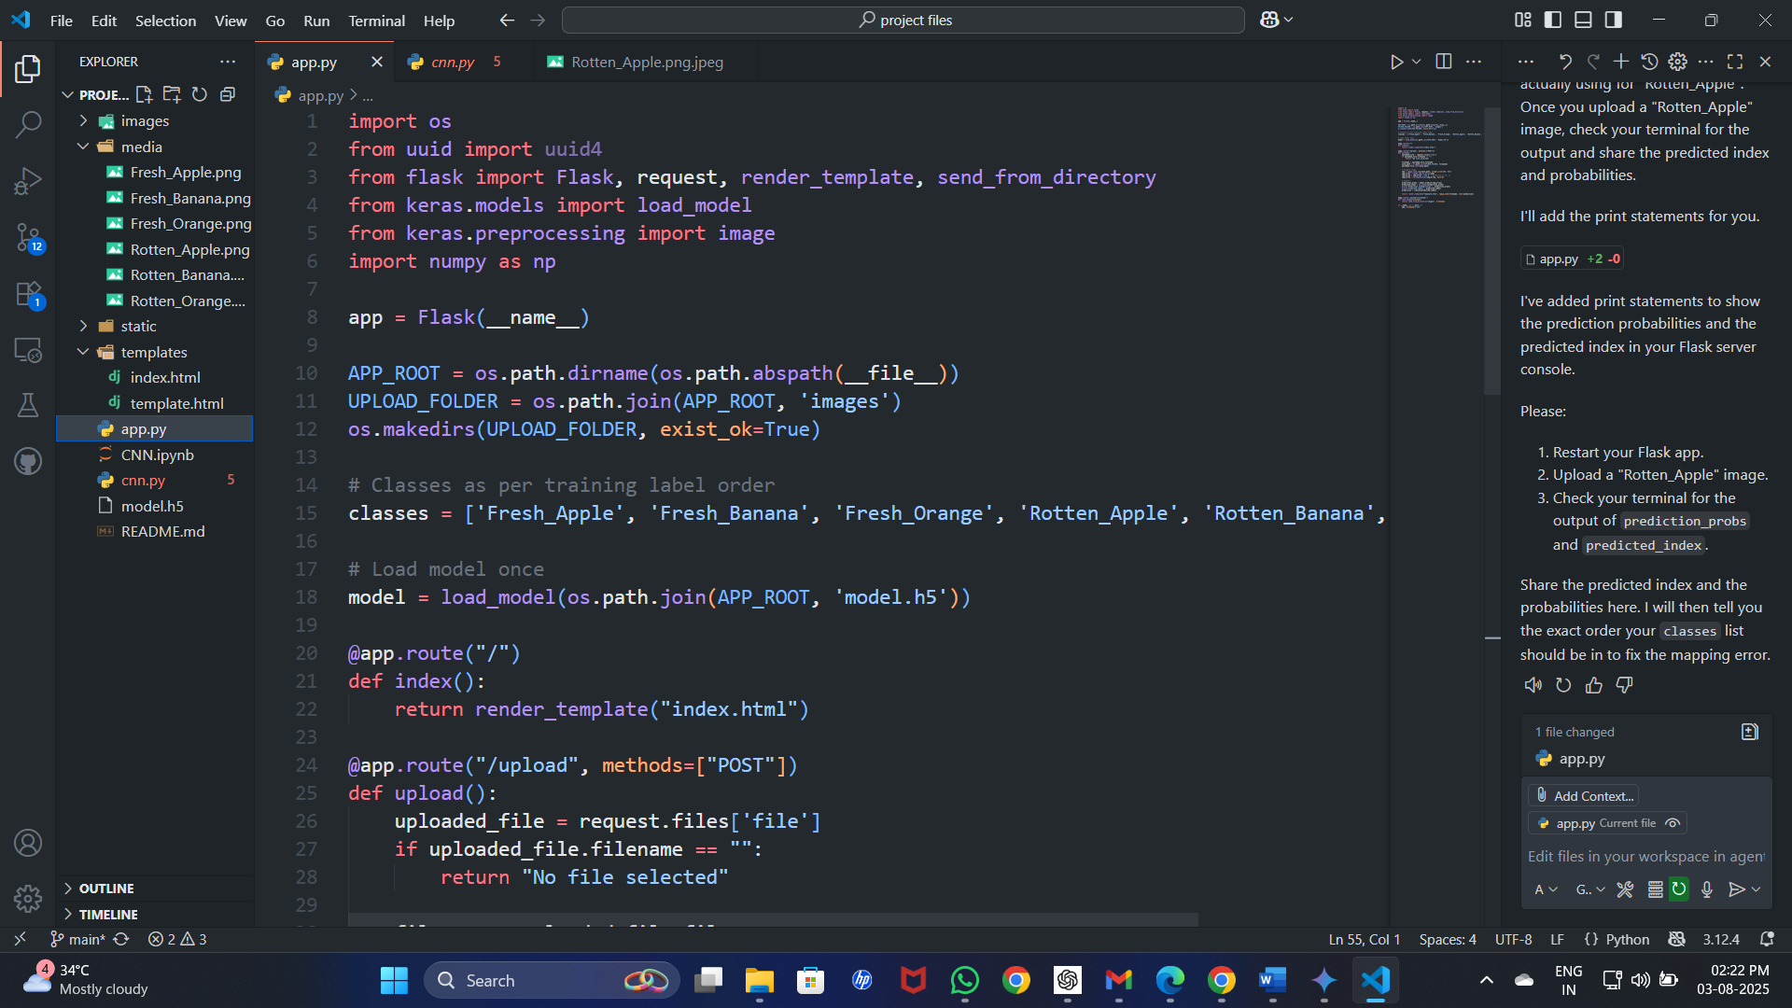
3. | Utilization of Filters | Slicers used: by Category (Fruit/Vegetable), Condition (Fresh/Rotten), Upload Date  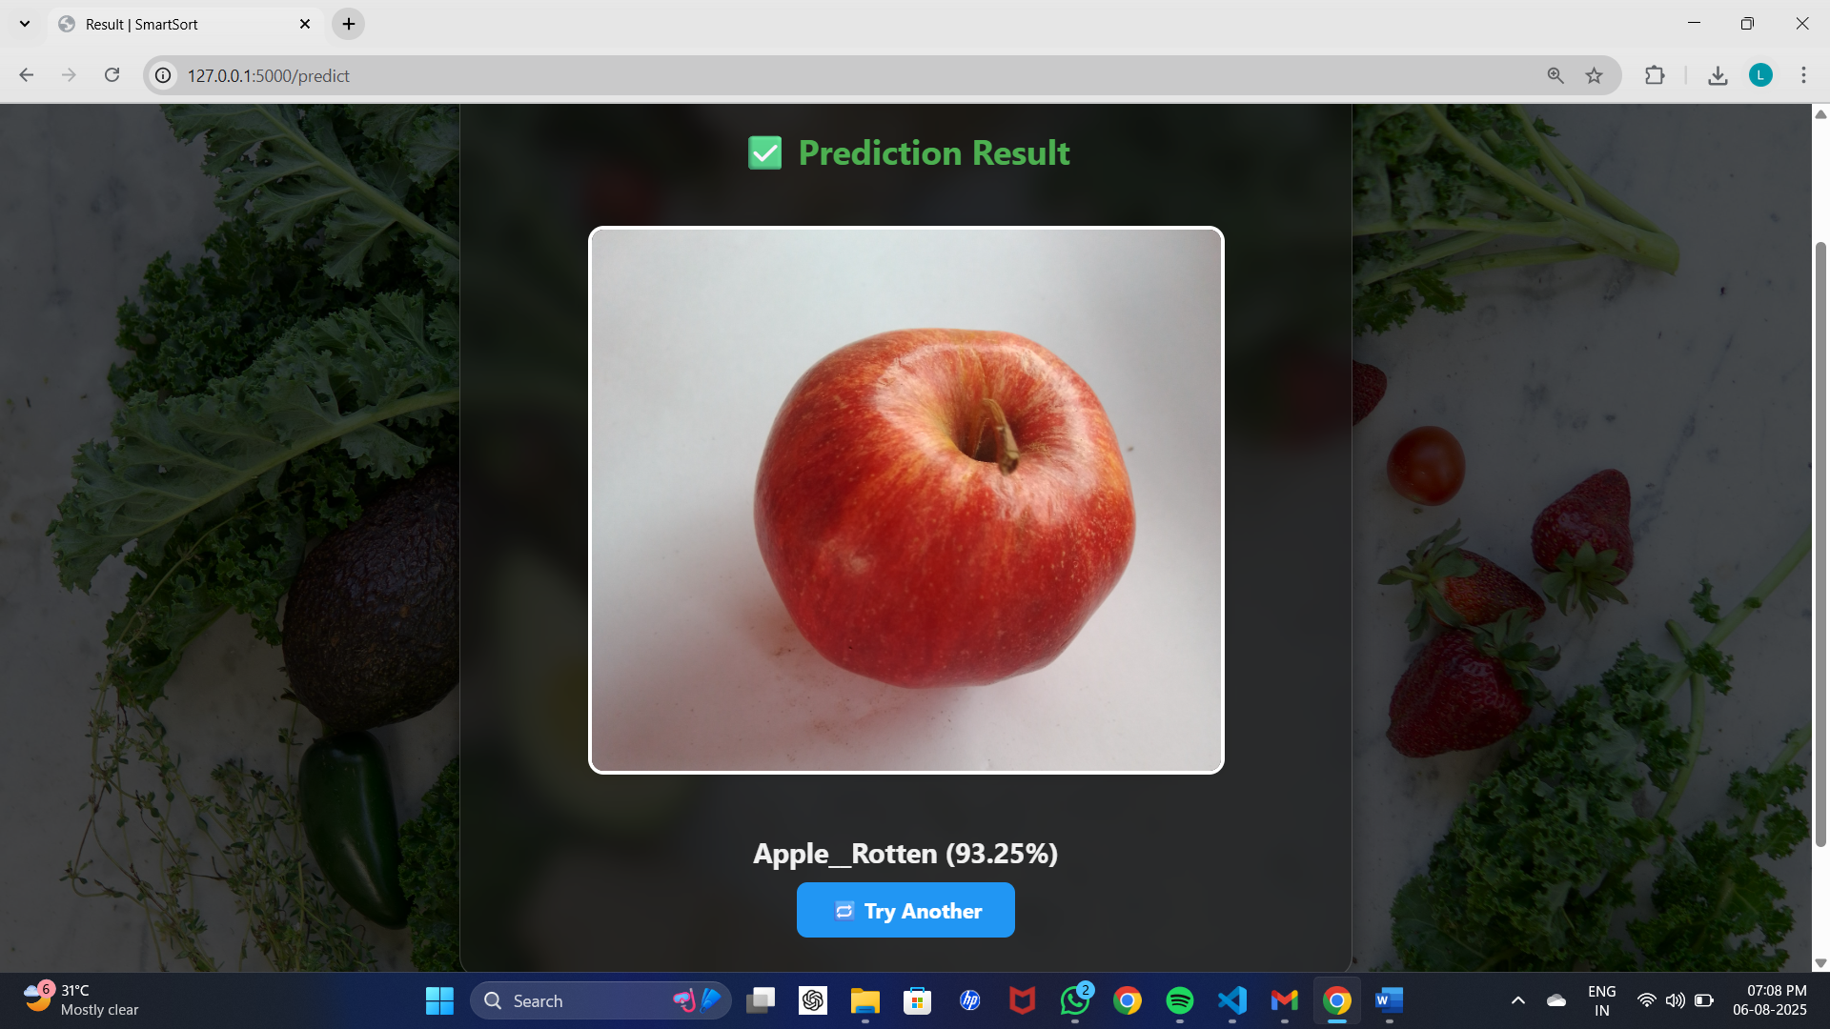  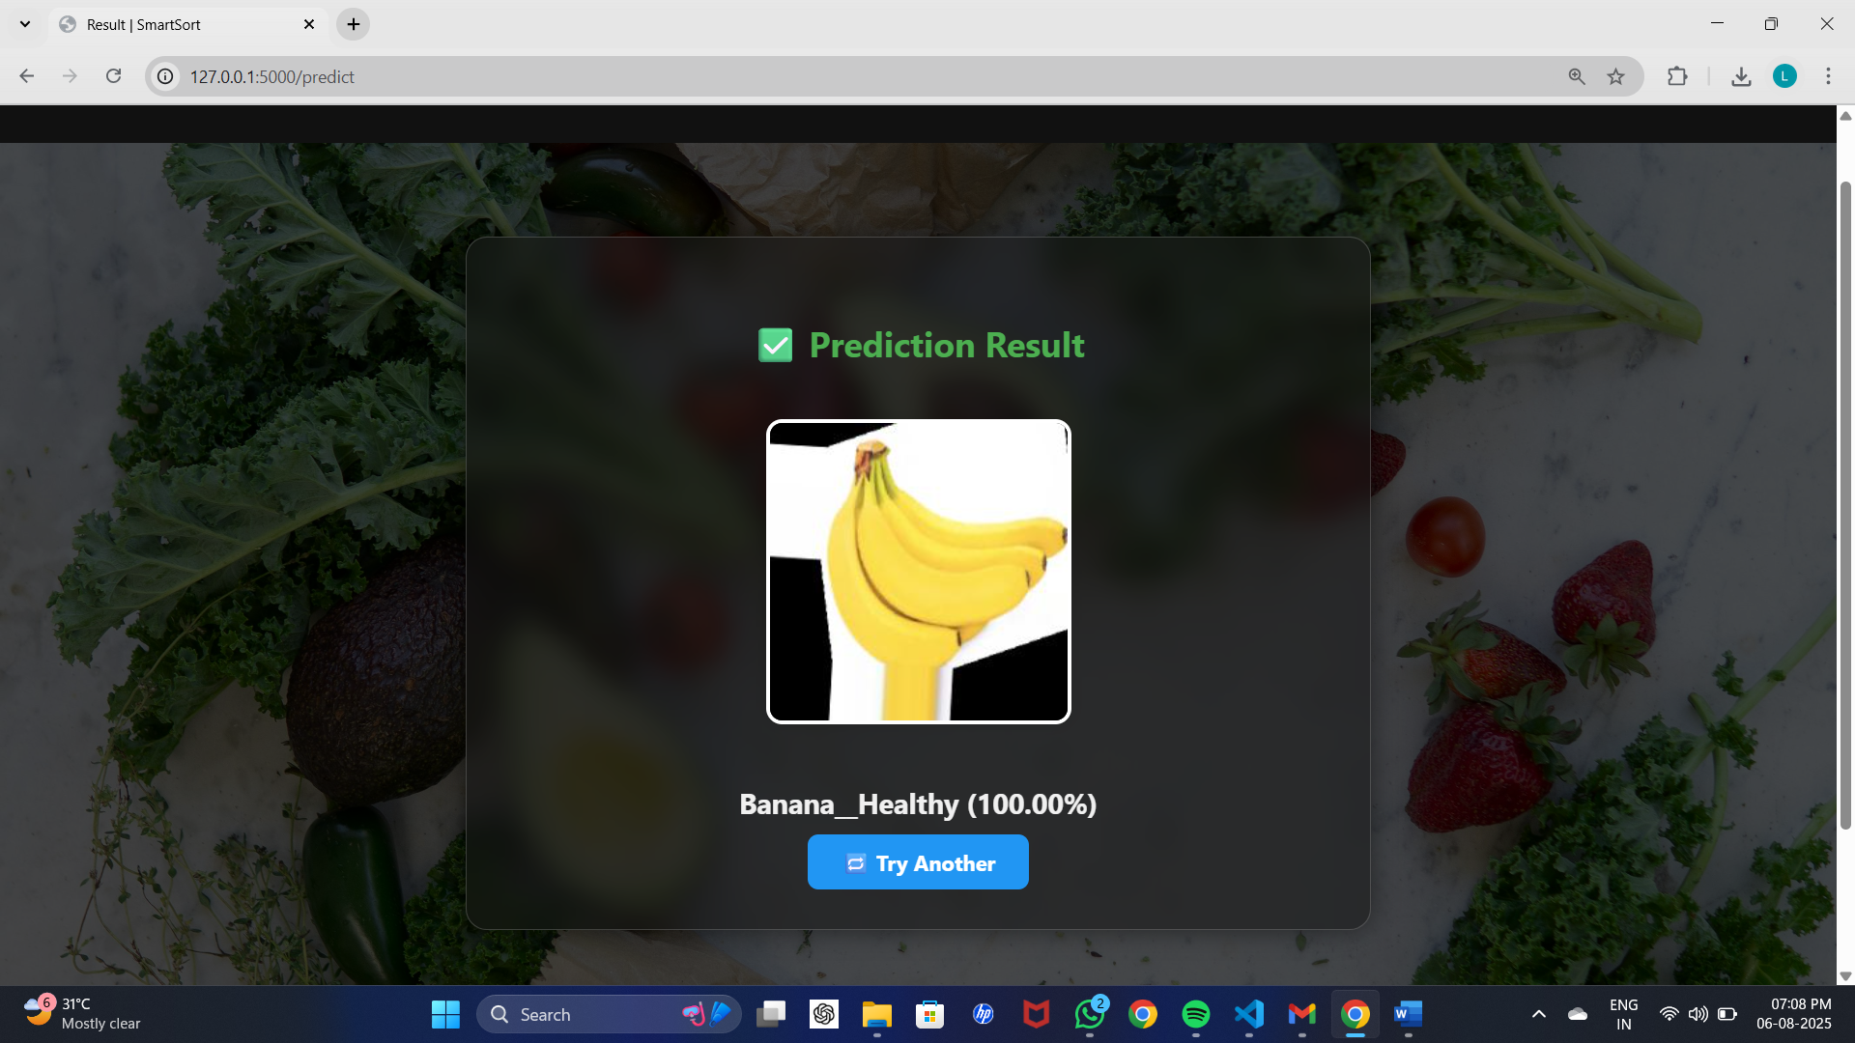
4. | Calculation fields Used | • CALCULATE() for filtered accuracy  • IF() for pass/fail result columns
5. | Dashboard design | No. of Visualizations / Graphs – 6  Includes pie charts, bar charts, accuracy over time line chart  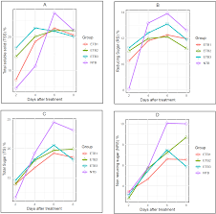
6 | Story Design | No. of Visualizations / Graphs – 4  Includes detailed data table, filters, and KPI cards  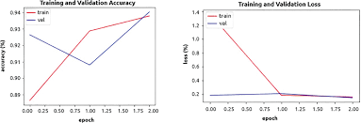
 |  | 